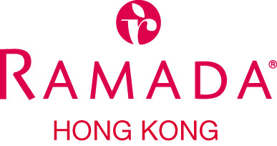

"The 1st International Conference on Food Safety"
by
The University of Hong Kong

16 – 18 June 2014

HOTEL RESERVATION FORM
(Please use one form for each booking and type in all information)

GUEST NAME (Mr / Mrs / Miss) : | (IF ANY) SHARE GUEST (Mr / Mrs / Miss) :
ARRIVAL DATE : | DEPARTURE DATE :
ARRIVAL FLIGHT : | DEPARTURE FLIGHT :
EMAIL ADDRESS / FAX NUMBER (For us to return a confirmation to you) :

SPECIAL ROOM RATE  HK$780 (on room only basis)  HK$850 (with buffet breakfast for 1 person)  HK$920 (with buffet breakfast for 2 persons)  The above rates are on per room per night basis  and inclusive of 10% service charge.  ROOM TYPE : Superior Room | NO. OF ROOMS : __________
SPECIAL REQUEST
Smoking
Non-smoking
GUARANTEE (All reservations must be guaranteed by credit card to secure room space)
VISA MASTER JCB DINERS AMEX
Card Holder Name __________________________________________________________________
Card No. __________________________________________ Expiry Date _____________________

TERMS AND CONDITIONS
- All reservations are subject to room availability upon making reservation
- In case of any cancellation notice given less than 10 days prior to arrival or no-show on the arrival day, one night room charge penalty will be levied to the given credit card.
- For any further assistance, please contact Ms Suzanie Chan, Assistant Director of Sales - Corporate at tel (852)3410 3329 or fax (852)2858 2969 or email adoscorp@ramadahongkong.com

Please complete and return this form to Reservations Department
on or before 15 May 2014
via fax no : +852 2548 5014 or email : res@ramadahongkong.com

308 Des Voeux Road West, Hong Kong
Tel : +852 3410 3333 Fax : +852 2559 8499
E-mail : hotel@ramadahongkong.com
Web : www.ramadahongkong.com

